EIB Climate Survey — fourth edition
LUXEMBOURG, 1 February 2022
When shopping for a new car, the vast majority of Maltese people say they will opt for a hybrid or electric vehicle

The second part of the 2021-2022 EIB Climate Survey explores people’s views on climate change in a rapidly changing world. The results from this release focus on citizens’ individual behaviour and the actions they are taking to combat climate change.

- 75% of Maltese people feel they are doing all they can to fight climate change in their daily lives, but the majority believe that their compatriots are not doing the same
- 85% of Maltese car buyers say they would either choose a hybrid or electric car the next time they purchase a vehicle (18 points above the EU average), while 15% would opt for a petrol or diesel car
- 68% of Maltese respondents say they consider climate change when choosing a holiday destination
- 51% of young Maltese people consider climate change when looking for a job
- 41% of young Maltese people buy second-hand clothes instead of new ones

These are some of the results from the second release of the 2021-2022 Climate Survey published today by the European Investment Bank (EIB). The EIB is the lending arm of the European Union and the world’s largest multilateral lender for climate action projects.
Hybrid or electric cars more sought after than petrol or diesel vehicles
When asked about future car purchases, 85% of Maltese car buyers say they would either buy a hybrid or electric car. This figure is 70 points higher than the percentage of Maltese who said they would buy a diesel or petrol vehicle (15%). More specifically, 49% would purchase a hybrid vehicle and 36% would opt for an electric vehicle.
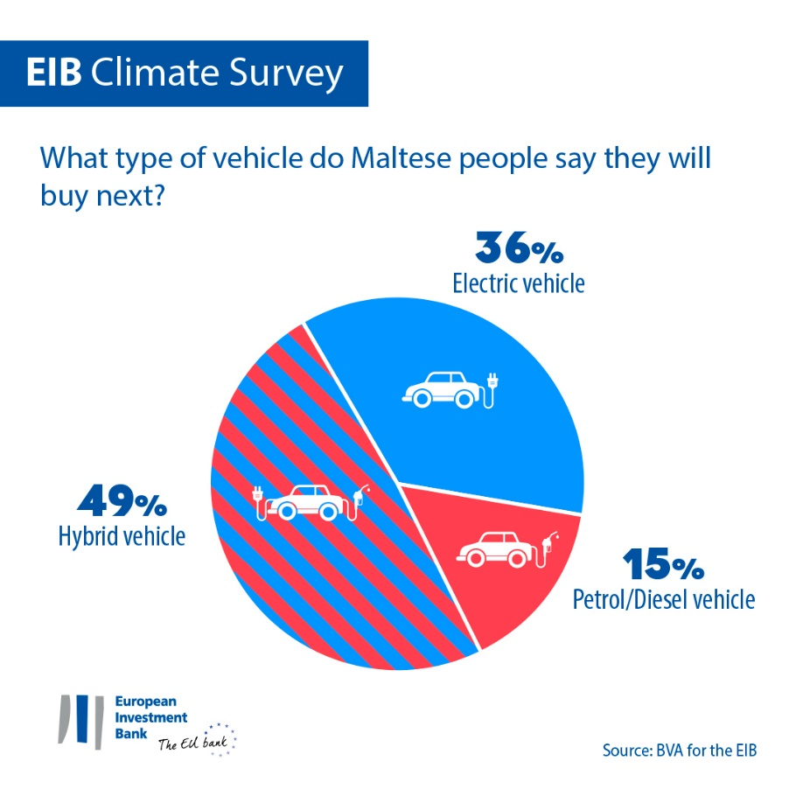
Maltese car buyers aged 30-64 are particularly interested in purchasing a hybrid vehicle (47%), while young people (aged 15-29) are more likely to choose an electric vehicle (42%). Petrol or diesel vehicles seem to be the least preferred option amongst Maltese respondents: only 28% of young people and 14% of people aged 30-64 would purchase a petrol or diesel car.
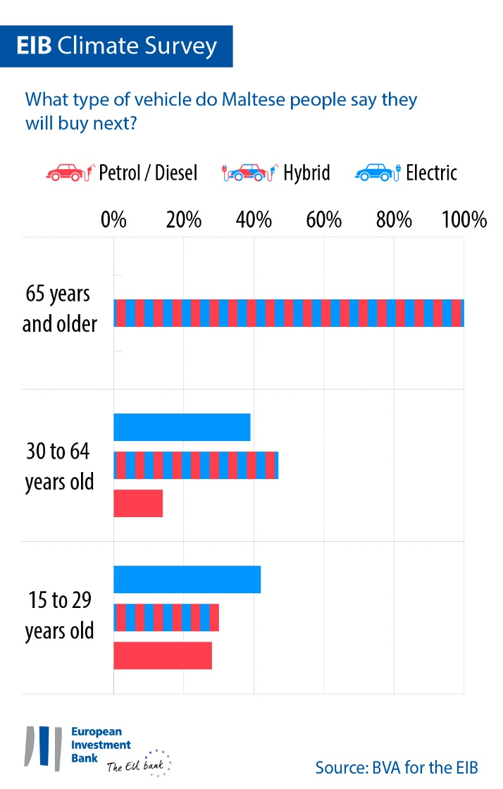
Meanwhile, 5% of the overall Maltese population say they do not have a vehicle now and are not planning to buy one (eight points below the EU average).
With 85% of Maltese car buyers saying they would opt for a hybrid or electric vehicle, they seem more inclined to switch to new car technologies compared to Italians (78%) and Germans (52%).
More specifically, Maltese car buyers seem particularly inclined to choose hybrid vehicles, with 49% of them stating their next car will have this type of engine, similar to Italians (51%). However, Maltese respondents are much more likely to want to purchase a hybrid compared to Germans (29%).
Maltese car buyers seem to be more inclined to purchase an electric car (36%) compared to Italians (27%) and Germans (23%).
In general, European car buyers tend to favour hybrid vehicles (39%), while petrol or diesel vehicles are ranked second (33%) and electric cars come third (28% state they would purchase an electric car). While Chinese car buyers are the most inclined to buy an electric car (44%), Americans would opt first for a hybrid vehicle (38%), followed by a petrol or diesel vehicle (33%), then an electric car (29%).
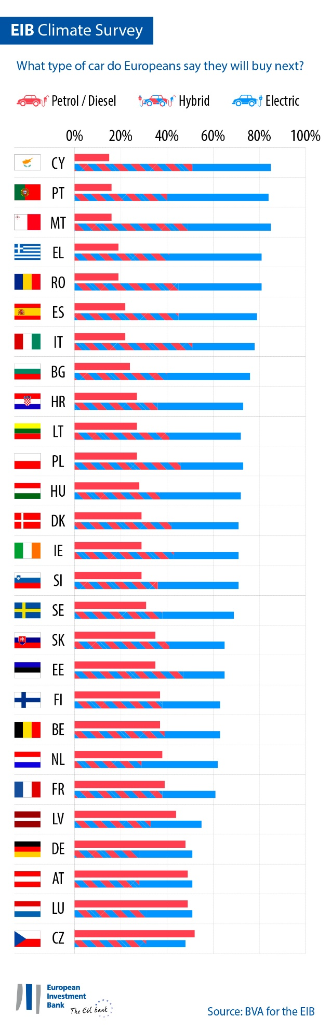
Shopping for clothes, choosing a job, deciding on a bank: how climate considerations affect people’s decisions
35% of Maltese people say they buy second-hand clothes instead of new ones (seven points below the EU average). Women are much more likely to do so than men (45% for women vs. 25% for men).
51% of Maltese respondents consider climate change when searching for a job (eight points above the EU average). In Malta, this is almost equally the case for 15-29 year-olds (51%) and people aged 30-64 (52%).
Overall, 56% of Maltese people consider climate change when they choose their bank or invest their savings (nine points above the EU average).
EIB Vice-President Gelsomina Vigliotti said: “Despite some clear generational gaps, Maltese people are increasingly adapting their mobility and consumption habits in a more sustainable manner to tackle climate change. These shifts in individual behaviour show that people of all ages are willing to make stronger commitments in their daily lives to help mitigate the climate crisis. These intentions were voiced during COP26 and are a clear indicator of support for our efforts to foster the green transition. As the EU climate bank, one of the EIB’s key roles is to finance innovative projects that focus on electric mobility as well as other sustainable mobility solutions that help build a decarbonised future for all.”
Download the Excel spreadsheet with the raw data for all 30 countries surveyed here. Please click here to access an EIB webpage presenting key findings of the EIB Climate Survey IV.
END

Media contact — Lorenzo Squintani (l.squintani@eib.org)
About the EIB Climate Survey
The European Investment Bank has launched the fourth edition of the EIB Climate Survey, a thorough assessment of how people feel about climate change. Conducted in partnership with market research firm BVA, the fourth edition of the EIB Climate Survey aims to inform the broader debate on attitudes and expectations in terms of climate action. More than 30 000 respondents participated in the survey between 26 August and 22 September 2021, with a representative panel for each of the 30 countries polled.
About the European Investment Bank
The European Investment Bank (EIB) is the long-term lending institution of the European Union and is owned by the EU Member States. It makes long-term finance available for sound investment in order to contribute towards EU policy goals both in Europe and beyond. The European Investment Bank is active in around 160 countries and is the world’s largest multilateral lender for climate action projects. The EIB Group has recently adopted its Climate Bank Roadmap to deliver on its ambitious agenda to support €1 trillion of climate action and environmental sustainability investments in the decade to 2030 and to deliver more than 50% of EIB finance for climate action and environmental sustainability by 2025. As part of the roadmap, all new EIB Group operations have also been aligned with the goals and principles of the Paris Agreement since the start of 2021.
About BVA
BVA is an opinion research and consulting firm recognised as one of the most innovative market research firms in its sector. Specialised in behavioural marketing, BVA combines data science and social science to make data inspiring and bring it to life. BVA is also a member of the Worldwide Independent Network of Market Research (WIN), a global network of some of the world’s leading market research and survey players, with over 40 members.

