LUXEMBOURG, 27 October 2021
EU citizens and Britons sceptical about successfully reducing carbon emissions by 2050, American and Chinese respondents more confident.
The first release of the 2021-2022 EIB Climate Survey explores people’s views on climate change in a rapidly changing world. The results from this release focus on how people perceive climate change and the actions they expect their country to take to combat it.

- In all countries surveyed, climate change is seen as the biggest challenge for humanity in the 21st century.
- The majority of EU citizens (58%) and Britons (55%) believe that their country will fail to drastically reduce its carbon emissions, as pledged in the Paris Agreement.
- 75% of EU citizens, 69% of Britons and 59% of Americans believe they are more concerned about the climate emergency than their governments.
- 70% of EU citizens and 73% of Britons are in favour of strict government measures imposing changes on people’s behaviour to fight climate change.

Only Chinese respondents (93%) and a slight majority of Americans (51%) believe their country will meet its reduced carbon emission commitments by 2050, as pledged in the Paris Agreement. Only a minority of EU citizens (42%) and Britons (45%) believe that their country will succeed in drastically reducing its carbon emissions.
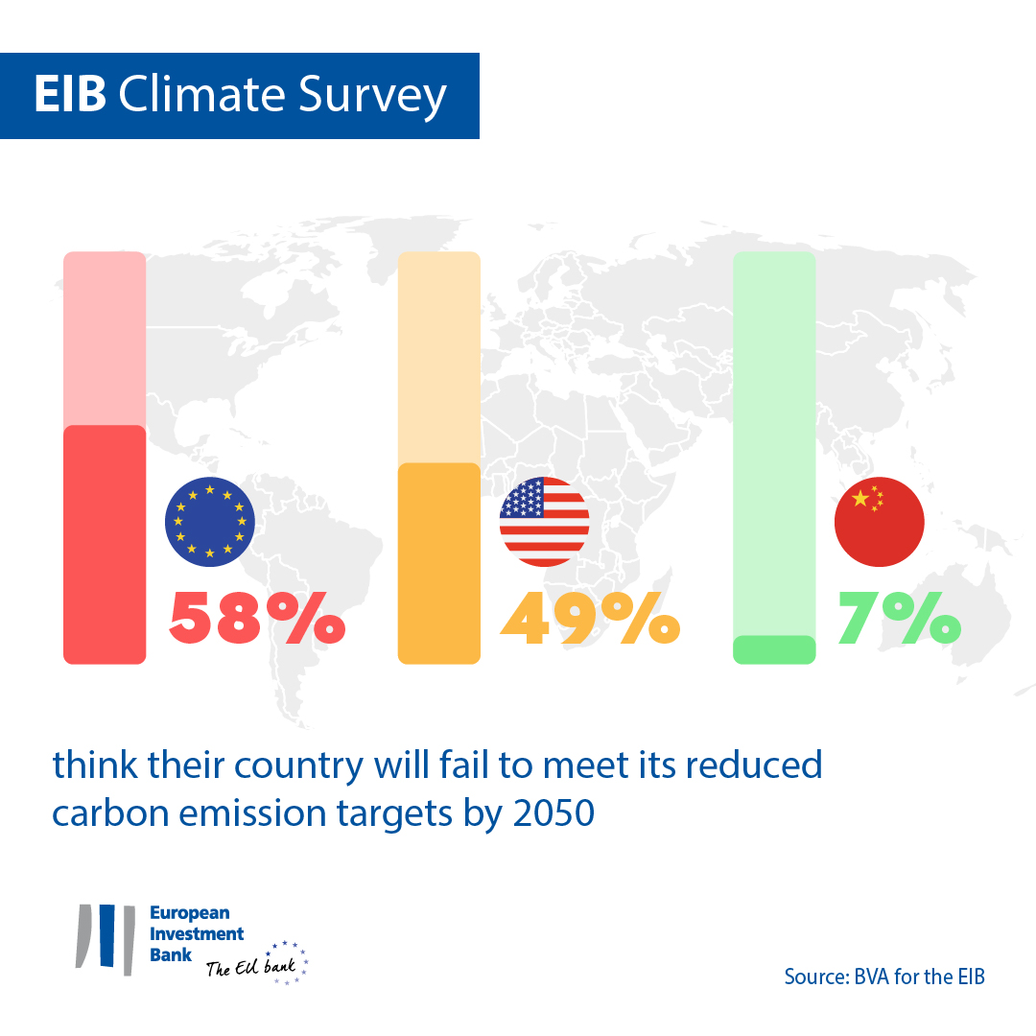
Meanwhile, the majority of citizens in the European Union, the United Kingdom, the United States and China believe climate change and its consequences are the biggest challenge for humanity in the 21st century. This figure is highest amongst Chinese respondents, with 93% agreeing with this statement, followed by EU citizens (81%), the British (74%) and Americans (59%). In the European Union, United Kingdom and United States, younger people are more convinced of the severity of the climate crisis than older generations.
These are some of the results from the first part of the 2021-2022 Climate Survey published today by the European Investment Bank (EIB). The EIB is the lending arm of the European Union and the world’s largest multilateral lender for climate action projects.
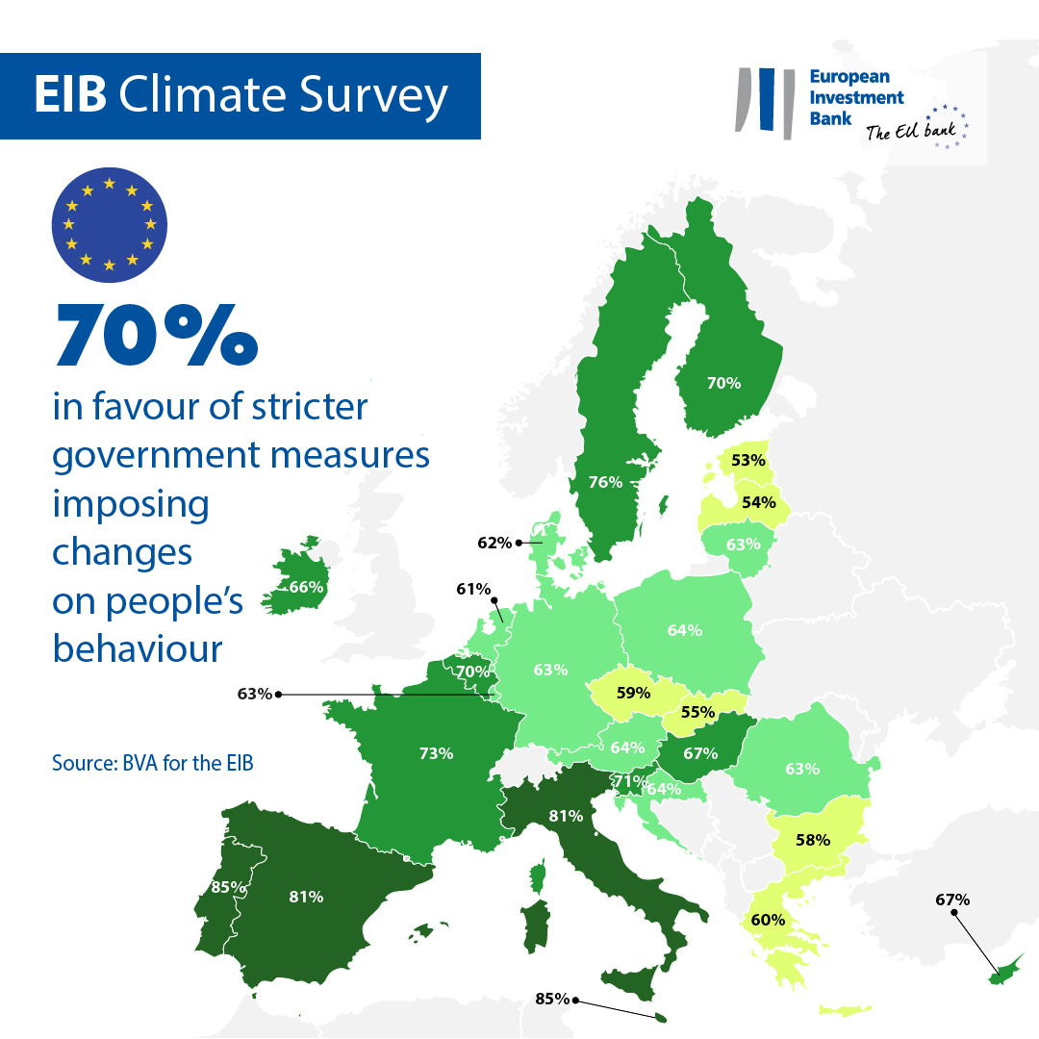
The public in the West expects stronger action from its governments, while Chinese respondents emphasise individual responsibility
EU citizens (75%) and Britons (69%) believe that they are more concerned about the climate emergency than their governments. Americans agree with this statement, but to a lesser extent (59%). 51% of EU citizens, 49% of Britons and 41% of Americans say it is difficult to solve the climate crisis because their governments are not active enough.
In contrast, Chinese respondents (69%) believe that their government is more concerned than citizens themselves about the climate emergency. 41% say the main reason why it is difficult to solve the climate crisis is that people do not want to change their behaviour.
Around the world, people are in favour of stricter measures that impose changes on people’s behaviour to tackle the climate crisis: 91% of Chinese respondents, 73% of Britons, 70% of EU citizens and 60% of Americans would support these measures.
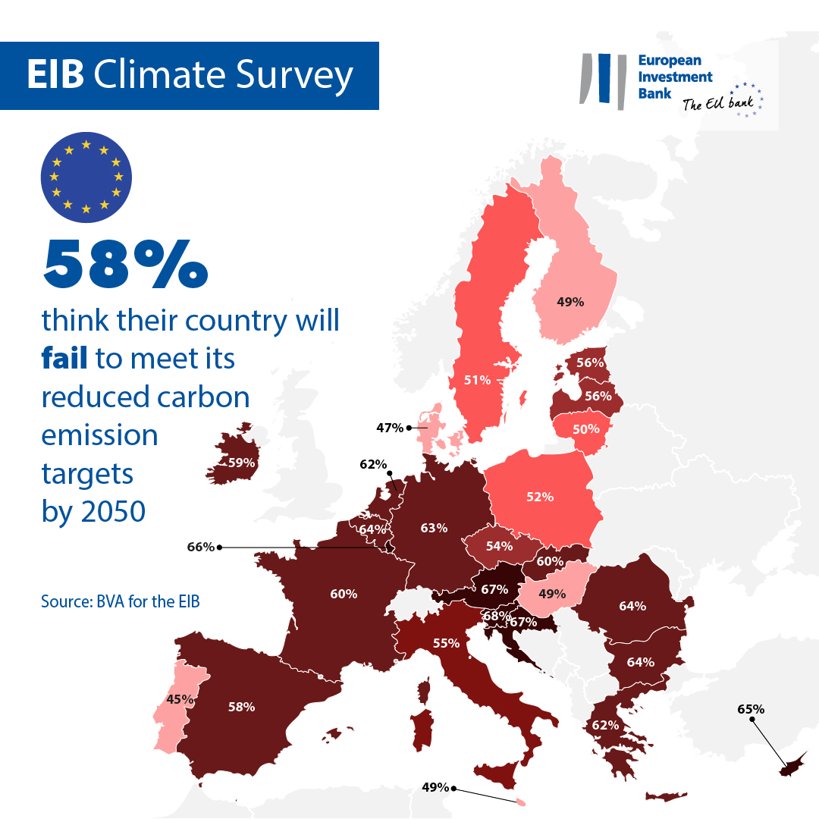
The energy debate
When asked about the source of energy their country should rely on to fight global warming, citizens from all regions emphasise using renewable energies. While EU citizens (63%), Britons (59%) and Chinese (60%) are predominantly in favour of renewable energies, the same is true of only 50% of Americans.
Support for natural gas as a transition source of energy is low, but relative to other sources there is more support among Americans (18% in favour of natural gas) than other regions (13% are in favour in China, 9% in the United Kingdom and 6% in the European Union). Nuclear energy is a more popular option for Britons (15%) and EU citizens (12%) than for Americans (9%) and Chinese respondents (5%).
Finally, for many respondents the most sustainable energy source for addressing the climate crisis is the one we don’t use: 22% of Chinese respondents, 17% of Americans and EU citizens, and 16% of Britons say energy savings should be the priority.

Most popular solutions to fight climate change
Across the world, people say they are in favour of imposing a warranty of a minimum of 5 years on any electric or electronic product: 93% of Chinese respondents, 91% of EU citizens, 87% of Britons and 77% of Americans would support this measure.
In addition, strengthening education and increasing children’s awareness of sustainable consumption should be a priority, according to 93% of Chinese respondents, 92% of EU citizens, 88% of Britons and 81% of Americans.
The adoption of a tax on products and services that contribute most to global warming would be welcomed by a majority of citizens in all regions (69% in favour in the European Union, 71% in the United Kingdom, 62% in the United States and 89% in China).

EIB Vice-President Ambroise Fayolle said: “Despite some generational and sociodemographic divides, a strong majority of people in all countries polled want stricter measures and tools, such as cleaner energy sources, to help them fight climate change. In the run-up to COP 26, this strengthens our determination to increase our efforts and accelerate the ecological transition. As the European climate bank, the role of the EIB is to finance projects focus on clean energy, energy savings, sustainable mobility solutions and innovations that help limit the rise in temperature to 1.5 °C or less.”
Download the Excel spreadsheet with the raw data for all 30 countries surveyed here. Please click here to access the EIB website page that presents the key findings of the EIB Climate Survey IV.

END

Media contact – Thomas Fromovici (t.froimovici@eib.org)
About the EIB Climate Survey
The European Investment Bank has launched the fourth edition of the EIB Climate Survey, a thorough assessment of how people feel about climate change. Conducted in partnership with market research firm BVA, the fourth edition of the EIB Climate Survey aims to inform the broader debate on attitudes and expectations in terms of climate action. More than 30 000 respondents participated in the survey between 26 August and 22 September 2021, with a representative panel for each of the 30 countries polled.
About the European Investment Bank
The European Investment Bank (EIB) is the long-term lending institution of the European Union and is owned by the EU Member States. It makes long-term finance available for sound investment in order to contribute towards EU policy goals both in Europe and beyond. The European Investment Bank is active in around 160 countries and is one of the world’s largest multilateral lenders for climate action projects. The EIB Group has recently adopted its Climate Bank Roadmap to deliver on its ambitious agenda to support €1 trillion of climate action and environmental sustainability investments in the decade to 2030 and to deliver more than 50% of EIB finance for climate action and environmental sustainability by 2025. As part of the Roadmap, all new EIB Group operations have also been aligned with the goals and principles of the Paris Agreement since the start of 2021.
About BVA
BVA is an opinion research and consulting firm recognised as one of the most innovative market research firms in its sector. Specialised in behavioural marketing, BVA combines data science and social science to make data inspiring and bring it to life. BVA is also a member of the Worldwide Independent Network of Market Research (WIN), a global network of some of the world’s leading market research and survey players, with over 40 members.

